Association between inferior vena cava variability indices and pulmonary ultrasound patterns in fluid resuscitation in patients admitted to intensive care.
Tapia Garcia Christopher¹, Esparza Correa Josué Gerardo¹, Visoso Palacios Porfirio¹, Jacinto Flores Sarahi Anilu¹.

¹ Intensive Care Unit, Central South High Specialty Hospital of Petróleos Mexicanos. Mexico City.
Email: christophtag@gmail.com

How to cite this paper: Author 1, Author 2 and Author 3 (2026) Paper Title. Open Access Library Journal, 13: ****.  https://dx.doi.org/10.4236/***.2026.*****  Received: **** **, ***  Accepted: **** **, ***  Published: **** **, ***  Copyright © 2026 by author(s) and Open Access Library Inc.  This work is licensed under the Creative Commons Attribution International License (CC BY 4.0).  http://creativecommons.org/licenses/by/4.0/ |  |  | Abstract  Proper assessment of cardiac preload, volume response, and signs of fluid overload are fundamental for fluid resuscitation. Ultrasound is a useful non-invasive tool for estimating these parameters through the analysis of inferior vena cava variability and pulmonary patterns. This observational, longitudinal, and retrospective study included 41 patients admitted to the ICU of the Central South High Specialty Hospital of Petróleos Mexicanos. Objective: To establish the association between inferior vena cava variability indices and pulmonary ultrasound patterns in fluid resuscitation in patients admitted to intensive care. Material and methods: IVC distensibility or collapsibility indices and A and B lines were evaluated on pulmonary ultrasound (LUS) at 0, 15, 30, and 45 minutes of fluid resuscitation Results: “First measurement: p = 0.026, OR = 1.167 (CI 0.862–1.579). Although the p-value was significant, the confidence interval included 1.0, indicating a statistically weak association with limited precision.” Subsequent assessments showed no statistical significance. The mean volume of fluids administered was 796.7 ± 352.6 mL, and the observed mortality rate was 7%. Discussion: These findings suggest that combining IVC ultrasound and LUS allows for more targeted, safer, and more efficient resuscitation with a lower risk of fluid overload.  Subject Areas  Critical care medicine.  Keywords  Lung ultrasound, Vena Cava, Volume response, Fluid resuscitation.

**Special description of the title. (dispensable)
1. Introduction
Reliable assessment of cardiac preload, volume responsiveness, cardiac output (CO), and also indicators of possible fluid overload (extravascular lung water, EVLW) are prerequisites for the successful management of hemodynamically unstable patients Lung ultrasound is based on the fact that every acute disease reduces lung aeration, changing the lung surface and generating distinct and predictable patterns; this allows for the diagnosis of conditions and the monitoring of therapeutic interventions.[1]
1.1 Vena cava ultrasound
Assessing fluid responsiveness is key to the successful resuscitation of critically ill patients requiring aggressive fluid therapy. The use of the vena cava index variation is favored among dynamic methods for assessing fluid responsiveness in the Intensive Care Unit (ICU) because it is non-invasive and inexpensive; furthermore, it does not require a high level of training. Ahmed Nagi A 2021 publication in the Journal of Anesthesiology showed that 29 patients (50%) were considered responders, with an increase in cardiac output of 10% or more after fluid challenge. The study described a suggested cutoff value for the reference inferior vena cava collapsibility index (IVCI) to predict fluid infusion response as 32%, with a high probability of response above this value (sensitivity 72.41% and specificity 82.76%). The article concluded that IVCI assessment can be a sensitive and good predictor of fluid responsiveness, based on a safe and non-invasive technique compared to other methods such as central venous pressure (CVP) measurement and pulmonary artery catheter insertion.[2]
1.2Pulmonary Ultrasound-Limited Administration (FALLS) Protocol
This protocol is based on the fact that a predominance of the A line indicates dry interlobular septa and low or normal left atrial pressure. Whereas a predominance of the B line is associated with alveolar-interstitial syndrome, a disorder often a pre-radiographic and preclinical sign consistent with pulmonary edema.[3]
2. Material and Methods
2.1 Study Design
An observational, longitudinal, retrospective, and analytical study was conducted inpatients of the Central South High Specialty Hospital of Petróleos Mexicanos where the digital and physical clinical records of all patients over 18 years of age who were admitted to the intensive care service and who required fluid resuscitation during the first hour were assessed.
Universe
Patient records that were admitted to the Intensive Care Unit and required fluid resuscitation during the first hour.
Definition of the study universe
a) Patients who presented with perfusion alterations (macro and/or micro hemodynamics) that required resuscitation with fluid therapy and who had positive echocardiographic predictors of volume response during the first hour of detection.
2.2 Inclusion, exclusion and elimination criteria
Inclusion:
- Records of patients aged 18 years or older (no upper age limit).
- Patient records with records of ultrasonographic measurements (vena cava, and pulmonary ultrasound).
- Patients who required fluid resuscitation during the first hour of admission to intensive care.
Exclusion:
- Patients with myocardial performance abnormalities that do not allow for adequate evaluation: heart failure, renal failure, hepatic failure, arrhythmias, pulmonary thromboembolism, pericardial effusion, pulmonary hypertension
- Patients on mechanical ventilation who have PEEP >10 cmH2O.
- Patients with frozen abdomen.
- Patients with severe abdominal hypertension.
- Patients with absence of an adequate ultrasound window.
Elimination:
- Incomplete observation units or units not found for analysis
- Sample size
- A sample size of 37 patients was calculated, with a 95% confidence interval, taking into account a 5% margin of error, with a population proportion of 50% and a population size of 40 participants; in the end, 43 records were obtained; of which only 41 proceeded to the analysis of the ultrasound variables
2.2 Formulas used for calculating volume response using the vena cava index.
For ventilated patients, the inferior vena cava distensibility index was calculated: ≥ 15% = volume responder. Formula: (Maximum Diameter – Minimum Diameter) / Minimum diameter.
For non-ventilated patients, the inferior vena cava collapsibility index was calculated: ≥ 40% = volume responder. Formula: Maximum diameter - Minimum diameter/Maximum diameter.[4]
2.3 Procedure Description.
- Patient admitted to the service with clinical and/or laboratory signs of hypoperfusion documented with at least 2 of the following:
- Hypotension: documented mean arterial pressure <65 mmHg.
- Dehydrated mucous membranes.
- Oliguria < 0.5 milliliters/kilogram/hour.
- Hyperlactatemia4 mmol/L in septic patients and2 mmol/L in other diagnoses.
- Delayed capillary refill > 2 seconds.
- Primary assessment and stabilization (ABC of trauma).
3. Secondary evaluation, minute zero; performance of ultrasonographic measurements.
4. Begin rapid administration of 4 ml/kg crystalloid.
5. Apply vasopressors if hypotension persists during or after fluid resuscitation to maintain a MAP ≥ 65 mm Hg.
6. Performing ultrasound measurements with SONOSCAPE S1 equipment at 0, 15, 30 and 45 minutes, or until overload data is documented in the first hour, or until resuscitation is stopped.
7. Outcome Observation:
• Ultrasonographic signs of fluid overload (Lung B-lines >3, pleural effusion, inferior vena cava compliance index: ≤ 14% = volume responder, or inferior vena cava collapsibility index: ≤ 39% = volume responder.)
• Ultrasonographic signs of volume responsiveness (Presence of A lines in the lung, Lung B-lines ≤3, inferior vena cava distensibility index: ≥ 15% = volume responder, or inferior vena cava collapsibility index: ≥ 40% = volume responder.)
• Alive or dead
2.4 Data collection
Data were collected from the physical and electronic medical records of patients who met the inclusion criteria and recorded in an Excel database. Subsequently, a database was created in the SPSS statistical software, where the data were coded and statistical analysis was performed to identify the variables of interest. To maintain confidentiality and data protection, the information was stored electronically on the student's laptop in a password protected .xls file.
2.5 Statistical analysis plan.
For the comparison of nominal categorical variables, the chi-square test for homogeneity was used. A p-value less than 0.05 was considered significant.
The chi-square test was used to assess the association between nominal categorical variables. A p-value less than 0.05 was considered statistically significant.
2.6 Ethical Considerations
In accordance with the ethical standards of the Declaration of Helsinki and Article 17 of the Regulations of the General Health Law on Health Research, patient participation in this study carries a minimal type of risk.
3. Results
During the study period from March 2024 to February 2025, 43 records were obtained, from which demographic data and indices, anthropometric and administrative data, and vena cava variability indices (collapsibility percentage and distensibility percentage), as well as pulmonary ultrasound patterns, were collected. Two records were excluded due to poor ultrasound window; no records were deleted.
3.1 Patient description
Of the 43 files initially analyzed, the patients had an average age of 64.8 ± 16; there were 22 men (51.2%) and 21 women (48.8%); the mean and standard deviation of weight, height, body mass index, and body surface area were 72.7 ± 18.4, 1.64 ± 0.95, 33.4 ± 43.3, and 1.71 ± 0.24, respectively. Regarding comorbidities, hypertension was present in 22 patients (51.2%); diabetes in 17 patients (39.5%); chronic kidney disease in 7 patients (16.3%); COPD in 4 patients (9.3%); heart failure in 6 patients (14%); and liver disease in 3 patients (7%). Regarding life support, 31 patients (72.1%) required mechanical ventilation; the average PEEP was 3.6 ± 2. The mean duration of mechanical ventilation was 1.29 ± 0.69 days. Regarding fluid administration criteria, 24 patients (55.8%) had hyperlactatemia; 38 patients (88.4%) hypotension; 32 patients (74.4%) oliguria; 27 patients (62.8%) delayed capillary refill; and 11 patients (25.6%) dehydration. Although 3 patients (7%) had arrhythmias, this did not contraindicate the measurement of the indices.
3.2 Ultrasound variability indices. Vena Cava and pulmonary pattern.
Following exclusion, of the 41 records analyzed, 30 (73%) had their distensibility calculated because they were on mechanical ventilation, while 11 records (27%) had their collapsibility calculated because they were not on mechanical ventilation (Figure 1). The results showed a mean and standard deviation of the maximum diameter of the inferior vena cava of 17 ± 4 millimeters a mean and standard deviation of the minimum diameter of the inferior vena cava of 11 ± 5 millimeters, with a mean and standard deviation of the initial percentage of variability of the inferior vena cava of 77 ± 86. The lung pattern was normal (showing A and B lines < 3 lines per scan field) in 40 patients (97.5%), and interstitial syndrome in 1 patient (2.5%) (Figure 2). The initial intervention was resuscitation in 40 patients (97.5%) and vasopressor administration in 1 patient (2.5%).

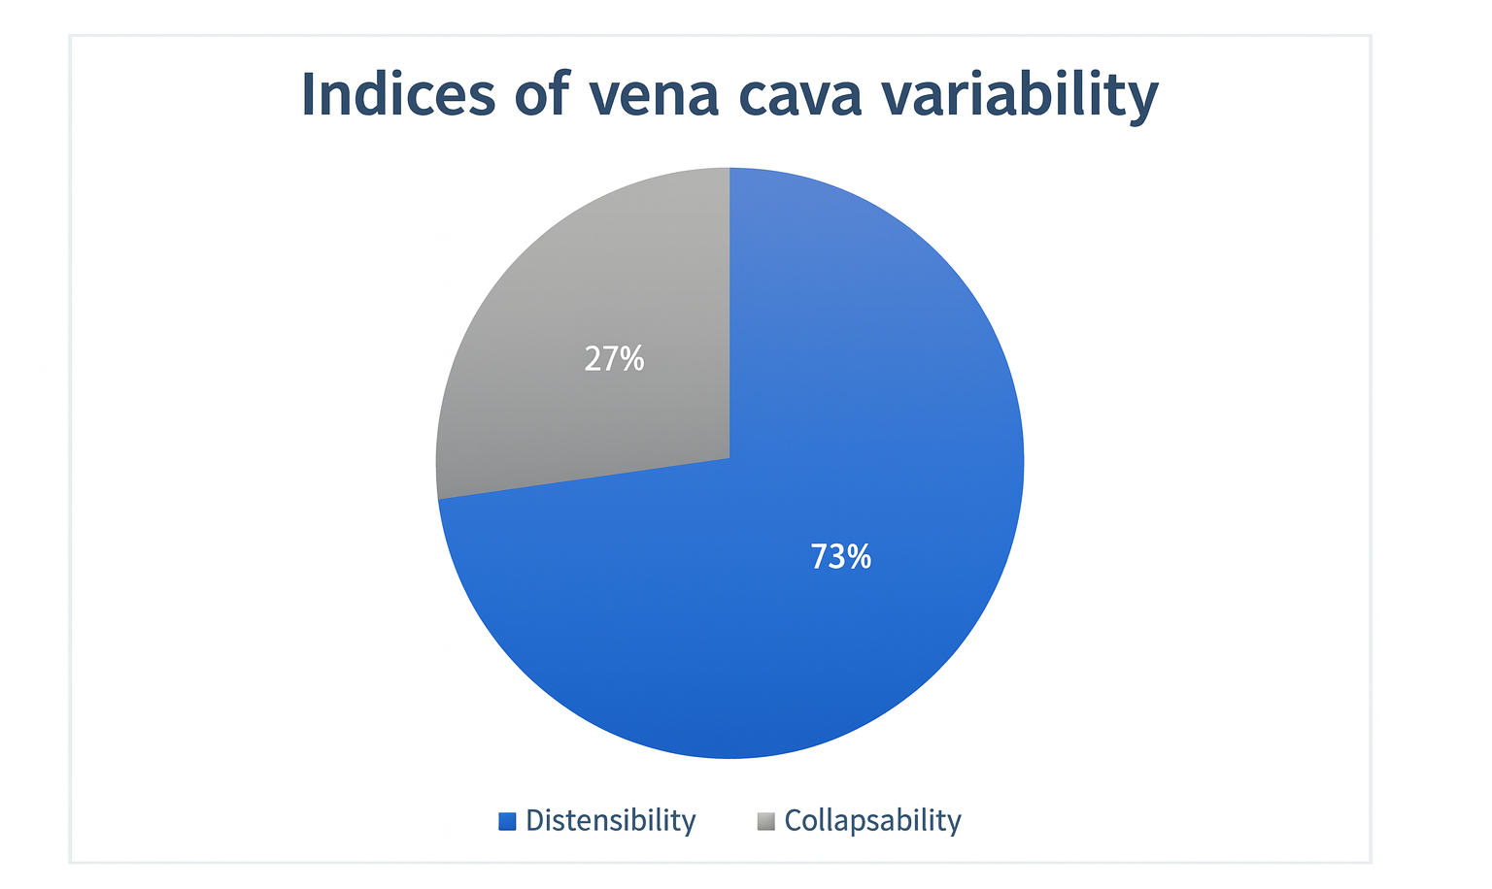
Figure 1. Indices of vena cava variability. Distribution of inferior vena cava variability indices in the study population. Distensibility accounted for 73% of measurements, while collapsibility represented 27%.
Of those who required fluid resuscitation; the mean and standard deviation of the standardized fluid bolus dose was 287.4 ± 75.4 milliliters, the mean and standard deviation of the total fluid dose was 796.7 ± 352.6 milliliters, the mean and standard deviation of the bolus indexed by Body Mass Index was 28.9 ± 9.2 milliliters/m2; the mean and standard deviation of the bolus indexed by Body Surface Area was 445.1 ± 161.6 milliliters/m2.
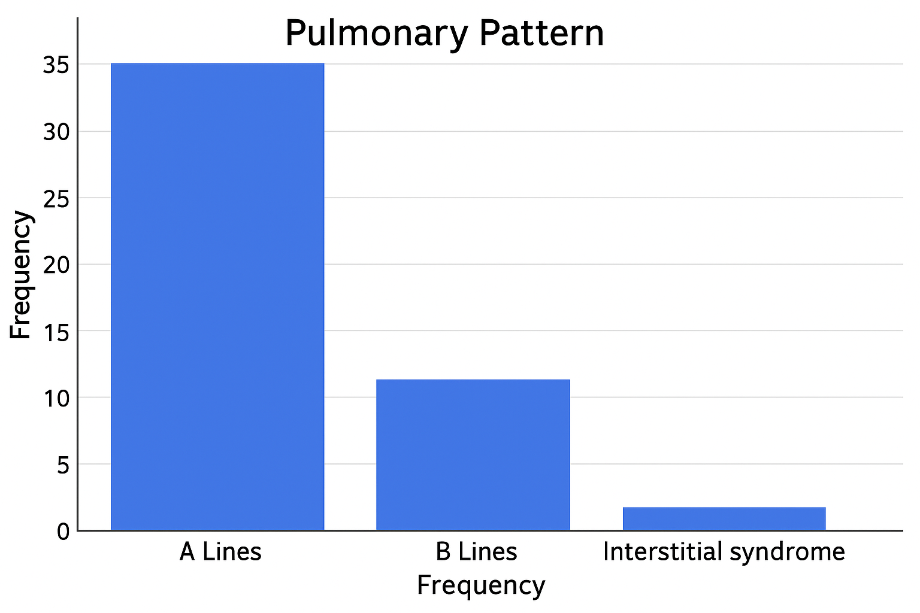
Figure 2. Pulmonary ultrasound pattern distribution. Frequency of lung ultrasound patterns observed in the study population. A-line pattern was the most prevalent, followed by B-lines, while interstitial syndrome was infrequent.
After 15 minutes, the second ultrasound measurements were performed in the patients who received volume, which showed a mean and standard deviation of the maximum diameter of the vena cava of 17.2 ± 4 millimeters, mean and standard deviation of the minimum diameter of the vena cava of 12 ± 5 millimeters, and the percentage of variability of the inferior vena cava of the second measurement was 48.2 ± 37, the lung pattern of the second measurement was normal (Lines A and B < 3) in 38 patients (92.6%), and interstitial syndrome in 3 patients (7.3%), the second intervention was resuscitation in 36 patients (87.8%) and cessation of resuscitation in 4 patients (9.7%), one patient died. A third measurement was performed in 36 patients in whom fluid resuscitation was continued. The mean and standard deviation of the maximum vena cava diameter was 17 ± 4 millimeters, the mean and standard deviation of the minimum vena cava diameter was 13 ± 4 millimeters, and the mean and standard deviation of the percentage of variability of the inferior vena cava was 38 ± 39 (Figure 3). The pulmonary pattern of the third measurement was normal (lines A and B < 3) in 23 patients (63.8%) and interstitial syndrome in 13 patients (36.1%). Therefore, the third intervention was resuscitation in 22 patients (61.1%) and discontinuation of resuscitation in 14 patients (38.8%), one patient died.
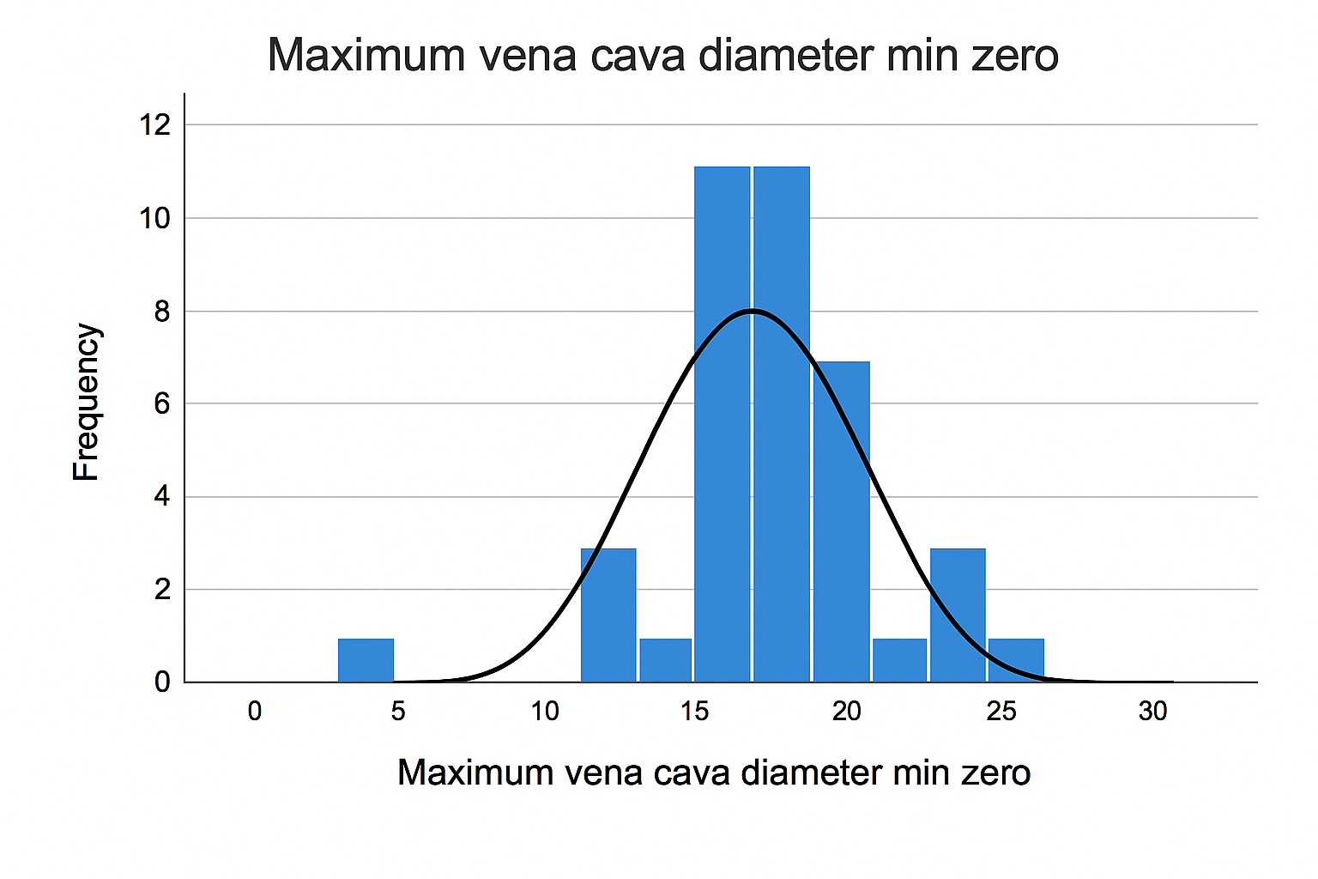
Figure 3. Maximum inferior vena cava diameter at time zero. Histogram showing the distribution of maximum inferior vena cava diameter measured at baseline (time zero), with an overlaid normal distribution curve.
A fourth measurement was performed in 8 patients who had available data to assess the variability indices of the inferior vena cava and the pulmonary pattern; the mean and standard deviation of the maximum diameter of the inferior vena cava was 19 ± 3 millimeters, the mean and standard deviation of the minimum diameter was 15 ± 3 millimeters, the mean and standard deviation of the percentage of variability of the inferior vena cava was 18 ± 14, the pulmonary pattern of the fourth measurement was normal (lines A and B < 3) in 6 patients (75%) and interstitial syndrome in 2 patients (25%), with which the intervention was: resuscitation in 5 patients (62.5%) and cessation of resuscitation in 3 patients (37.5%), one patient died.

3.3 Outcome variables
Vital status at discharge from intensive care was 38 patients alive (92.6%) and vital status at 28 days was 38 patients alive (92.6%).
3.4 Inferential statistics (risk analysis)
In the risk analysis of the first measurement, we found a chi-square with a p-value of 0.026, with an odds ratio of 1.167 and a confidence interval of 0.862 to 1.579 (Figure 4), which indicates statistical significance. Although the p-value was less than 0.05, the confidence interval included the null value (1.0), which suggests a statistically unstable or low-certainty association. In the second measurement, a Chi-square with a p-value of 0.276, with an odds ratio of 0.900 and a confidence interval of 0.799 to 1.014. In the third measurement, we found a chi-square test with a p-value of 0.319, an odds ratio of 0.485, and a confidence interval of 0.116 to 2.034. In the fourth measurement, we found a chi-square test with a p-value of 1.00, an odds ratio of 1.00, and a confidence interval of 0.41 to 24.547. (Figure 5).
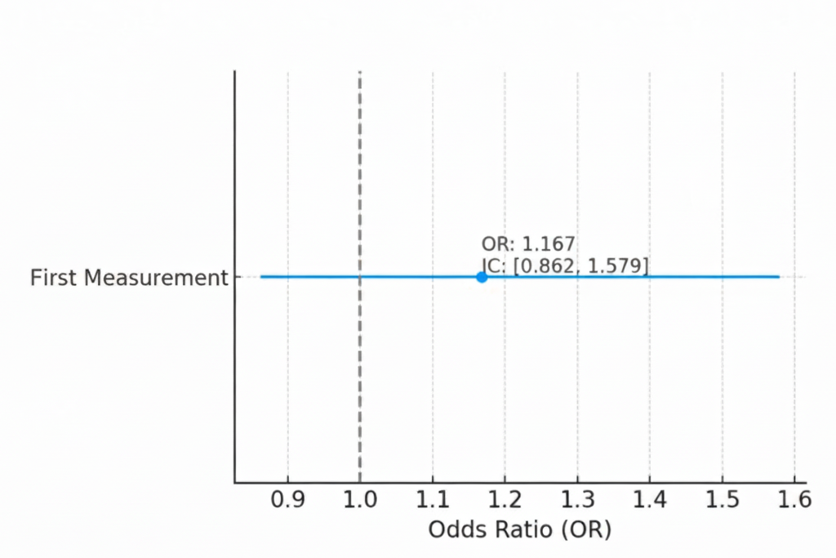
Figure 4. Risk analysis based on the first measurement. Forest plot showing the odds ratio (OR) and 95% confidence interval (CI) for the association between the first measurement and the study outcome. The dashed vertical line represents the null value (OR = 1).


Figure 5. Comparative forest plot of sequential measurements. Forest plot comparing odds ratios (ORs) and 95% confidence intervals (CIs) across the first, second, third, and fourth measurements. The dashed vertical line indicates the null value (OR = 1).
4. Discussion
Our study investigates the association between vena cava variability indices and the pulmonary ultrasound pattern with mortality outcomes in patients admitted to the intensive care unit. The patients included in our analysis belong to three main groups: sepsis and septic shock; neurocritical; and other diagnoses. The indication for fluid resuscitation was based on clinical variables of hypoperfusion, reflecting the individualized approach applied in our unit. Following the initial ultrasound evaluation, most patients were classified as responders by both vena cava ultrasound (82.9%) and lung ultrasound (97.5%). Initial volume administration was performed using a standardized bolus of 4 mL/kg, with a total mean of 287.4 ± 75.4 mL. Subsequent resuscitation sequences demonstrated that, even after multiple boluses, volume dependence progressively decreased according to ultrasound findings, allowing for timely discontinuation of fluid administration in several cases. The cumulative dose per patient was 796.7 ± 352.6 mL, considerably lower than that reported in classic trials such as Rivers (≈4981 mL in 6 h), PROMISE (≈2700 mL), and ARISE (≈1964 mL).[5,6,7]
To contextualize these differences, it is essential to recognize that the Rivers, PROMISE, and ARISE trials included only patients with severe sepsis or septic shock, constituting homogeneous populations with strict hypoperfusion criteria (refractory hypotension or elevated lactate). The resuscitation strategies in these studies aimed to aggressively correct the circulatory dysfunction characteristic of septic shock. In contrast, our cohort is more heterogeneous, with different pathophysiological profiles of hemodynamic instability. This clinical variability explains, at least partially, the smaller volumes administered, as therapeutic decisions were based on dynamic ultrasound findings rather than fixed resuscitation algorithms. The mortality rate observed in our cohort (7%) was lower than that reported in classic trials (between 18% and 30%). While these findings might suggest a potential benefit of a rational, image-guided resuscitation strategy focused on the concepts of “responder” and “requirer,” they should be interpreted with caution. Although a significant association was identified with first resuscitation, the confidence intervals for the odds ratio included 1, which limits the statistical robustness and emphasizes the need for studies with larger sample sizes.
Finally, our results reinforce the importance of integrating dynamic ultrasound variables into decision-making, allowing for the avoidance of excessive fluid administration and its potential complications. However, further research is needed to confirm these findings in larger, more homogeneous populations, and comparative studies with traditional resuscitation protocols should be interpreted considering the fundamental difference in the studied population.
4.1 Limitations of the study
This study has several limitations that should be considered when interpreting the results. First, the retrospective design relies on existing clinical records, which can introduce information bias and limit control over undocumented or inconsistent variables. Furthermore, the small sample size reduces the statistical power of the analysis and increases the imprecision of the estimates, as reflected in the wide confidence intervals and, in some cases, their crossing over to one. This limits the ability to establish conclusive associations between ultrasound indices and clinical outcomes. Another important limitation is that the study was conducted at a single center, which restricts the generalizability of the findings. Resuscitation practices, clinical criteria for initiating ultrasound, and staff experience may differ between institutions, so the results may not be applicable to other populations or clinical settings. Furthermore, the heterogeneous nature of the cohort, which includes septic, neurocritical, and other patients, while reflecting the dynamic reality of an intensive care unit, may hinder direct comparison with previous studies that analyzed more homogeneous populations.
For these reasons, prospective, multicenter studies with larger samples are required to validate the findings and more firmly establish the combined role of inferior vena cava variability and lung ultrasound patterns as tools to guide fluid resuscitation.
5. Conclusions
There is a significant association between inferior vena cava variability indices and lung ultrasound patterns during the first fluid resuscitation assessment in critically ill patients The use of combined ultrasound indices allows for more accurate, safe, and effective fluid resuscitation in critically ill patients.
In our study, administering a lower volume of fluids, based on clinical data and imaging studies, shows a trend toward improved survival. Further studies with more patients are needed to confirm these findings.
6. References
- Lichtenstein, D. (2010). Should lung ultrasonography be more widely used in the assessment of acute respiratory disease? Expert Review of Respiratory Medicine, 4(5), 533–538.
- Nagi, AI, Shafik, AM, Fatah, AMA et al. Inferior vena cava collapsibility index as a predictor of fluid responsiveness in sepsis-related acute circulatory failure. Ain-Shams J Anesthesiol 13, 75 (2021).
- Lichtenstein D, and Karakitsos D. Integrating lung ultrasound in the hemodynamic evaluation of acute circulatory failure (the fluid administration limited by lung sonography protocol). J Crit Care. 2012;27(5): 533.e11-9
- Ginghina C, Beladan CC, Iancu M, Calin A, Popescu BA. Respiratory maneuvers in echocardiography: a review of clinical applications. Cardiovasc Ultrasound. 2009 Aug 26; 7:42.
- Rivers E, Nguyen B, Havstad S, Ressler J, Muzzin A, Knoblich B, Peterson E, Tomlanovich M; Early Goal-Directed Therapy Collaborative Group. Early goal-directed therapy in the treatment of severe sepsis and septic shock. N Engl J Med. 2001 Nov 8;345(19):1368-77.
- ARISE Investigators; ANZICS Clinical Trials Group; Peake SL, Delaney A, Bailey M, Bellomo R, Cameron PA, Cooper DJ, Higgins AM, Holdgate A, Howe BD, Webb SA, Williams P. Goal-directed resuscitation for patients with early septic shock. N Engl J Med. 2014 Oct 16;371(16):1496-506.
- Mouncey PR, Osborn TM, Power GS, Harrison DA, Sadique MZ, Grieve RD, Jahan R, Harvey SE, Bell D, Bion JF, Coats TJ, Singer M, Young JD, Rowan KM; ProMISe Trial Investigators. Trial of early, goal-directed resuscitation for septic shock. N Engl J Med. 2015 Apr 2;372(14):1301-11.

